Meeting Questions
- DAC produces all voltage values? What is the maximum voltage range output of DAC?
  - We only need +-5V output

Questions for Lusher
- How to program the FPGA once its on the IC?
  - How will the board be programmed? Do I have to design a JTAG header into my board?
- Lookup table needs to be 64k long? Need external memory for that? Would I be using a clock to look up a value to look up another value?
  - Is 65536 the vertical resolution???
- Volatile FPGA?
- Minimum frequency? Or all the way down to 0? Trying to avoid using downsampling and variable clock at the same time
- Should I use the volatile board or non-volatile board?
- Voltage controlled oscillator? How to generate a variable voltage signal inside the FPGA/MCU? Numerically controlled oscillator? How many bits? Can it be created inside the FPGA?

what you were saying about the waveform generator producing 64k samples per second.

Does this only serve as the lower bound of the frequency? Is 100kHz, 10 samples/period the correct specifications for the upper bound of the frequency?

You were saying that the waveform generator needs to produce 64k samples per second, is this constant regardless of frequency, or is this a minimum value? Like, if a signal is produced at 1 Hz, does it need 64k samples per period of the waveform? And if the frequency was increased to 1 kHz, would the samples per period decrease to 64 so that the waveform generator is still producing 64k samples per second?

- Is external memory necessary, or can data be stored in latches in FPGA
  - If external memory is needed, how to interface with it, recommendations for memory ICs
    - Block ram memory
    - Is having a 1.2 V core a problem?
    - 64k samples 0 -
      - Ex 655535 samples at 10 hz
    - 65*2 bytes*2 channels = 256 k?
    - Ideally in a 32 bit format, 2 16s
      - Salina prefers 3.3V for VDD, VIO, VCCQ
    - Toshiba ram? Sram on digikey at least 128 k x 16 x 2 output waveforms
    - Use 2 memories if you have enough output lines
    - 16 address lines + control pins + data
    - Need a parallel dac
    - Everything needs to be parallel
    - 2 mega samples per second output
    - 32 megaheartz clock
    - Voltage controlled oscillator
    - Numerically controlled oscillator
    - Input x and y values with a csv file into the app
    - Highest frequency: 10 samples
    - Lowest frequency:
    - Linear region: all 64k go into DAC
    - Downsampling region: start downsampling, DAC is going at maximum frequency
    - Order IC: two weeks to order - board in by week of 10th of november, maybe sooner, order board mid october?
  - How to test FPGA without board connecting it to memory

- Recommendations for non ball grid FPGAs, had a hard time finding modern FPGAs that aren’t BGAs

- Would you recommend using parallel interfacing with DAC, or is serial sufficient considering speed constraints?
- Recommendations for how to construct an arbitrary waveform, retrieving binary values from memory or fourier transform?
- How different are FPGAs to each other? Would it be unwise to write code for a test board using a Spartan 6 to later implement it on a different FPGA?
- Should we use an external clock generator? Or generate it inside the FPGA or Microcontroller
  - Probably need an external clock generator

- Do we need to have an addition that sets us apart from the other teams, like not in the project deliverables? Just for the competition or required
- What did you mean by max sampling rate?
  - Only 10 sampling points per period?
- Minimum frequency?
- Engeti said to directly connect memory to DAC, we need two memories, one for preset and one for arbitrary waveforms??? Also said to use fourier transform?
- Who are we demoing for?

Test Board in lab: XLINUX Spartan 6 FPGA
- Probably only comes in BGA format

Yes SOIC, no BGA SOP QFN
- TQFP?

Connections
- https://docs.amd.com/v/u/en-US/ug385, page 274 & 30
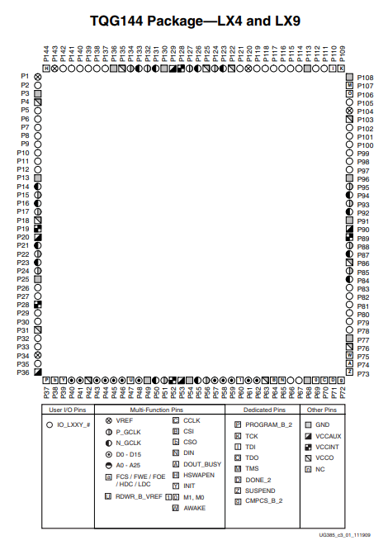
- 144 pins total
- 144 - 39 = 105 usable pins (39 VCC, GND, etc pins)
  - 16 per waveform, data output to DAC
  - __ data input lines from microcontroller
    - __ addressing lines
  - __ control lines from microcontroller
    - Counter reset value
    - Frequency?
    - Mode?
    - Type of data?

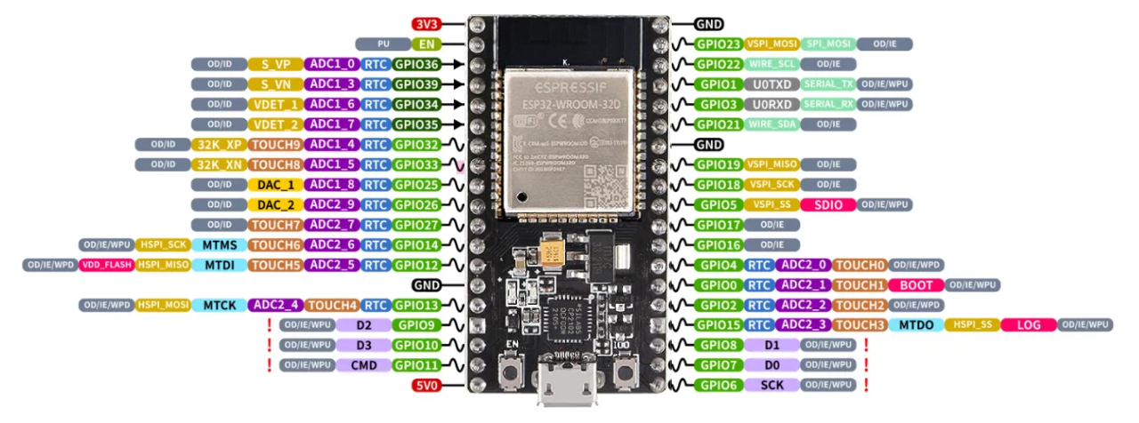

Links
- Frequency control method: https://en.wikipedia.org/wiki/Direct_digital_synthesis

Stats
- 2^16 = 65536 total samples, per channel
- Max sampling rate 1 MHz (datapoints per second?)
- Max frequency 100 kHz
  - 10 datapoints per period at maximum frequency
  - ??? datapoints per period at minimum frequency

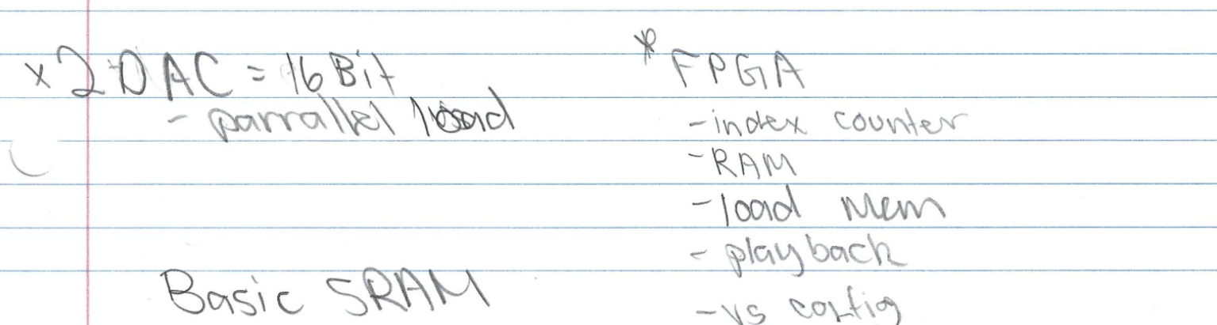

Definitions
- Resolution
  - Vertical resolution
  - Smallest controllable voltage increment
  - We are using 16 bits
- Frequency Resolution
  - Horizontal resolution
  - Smallest adjustable frequency increment
- Nyquist-Shannon sampling theorem - to perfectly reconstruct a continuous-time signal from its samples, the sampling rate must be greater than twice the highest frequency component in the signal

Frequency Range
- Lower bound:
  - 1 Hz frequency
  - 64k Samples/period
  - 64k Samples/second
  - 64kHz Clock
  - Constrained by samples/second specification
- Upper bound:
  - 100 kHz frequency
  - 10 Samples/period
  - 1M Samples/second
  - 1MHz Clock
    - Changes values every microsecond
    - Slew rate needs to be 10V/microsecond for ±5V output voltage range
  - Constrained by maximum frequency specification

Methodology
- Above 15 Hz
  - Clock is set at 1MHz
  - Frequency is controlled by the reset of the binary counter
  - 16 Hz: reset is at 64k
  - 100kHz: reset is at 10
  - Reset value needs to be calculated by the microcontroller
- 15 Hz to 0 Hz
  - Counter reset is always at 64k (highest value)
  - Clock speed is decreased to lower frequency
  - 15 Hz: clock is running at 1MHz
  - 0 Hz: clock is running at 0 Hz

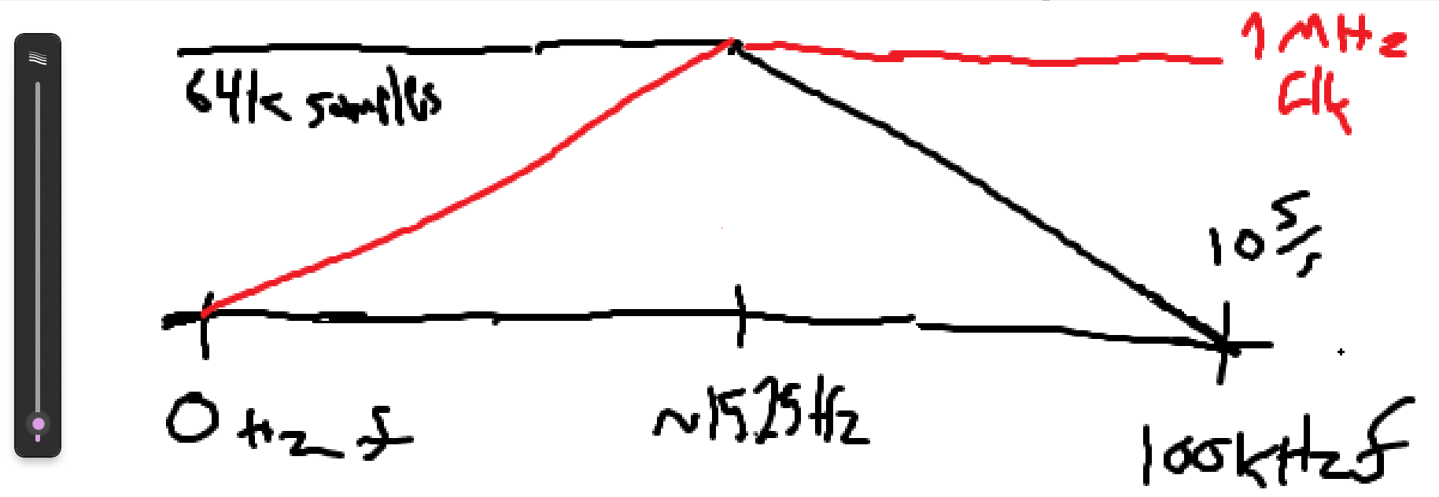
- Counter needs to be 16 bits wide, 16 D flip flops
  - The current value of the counter will be compared to a latched value from the MCU with a 16 bitwise XNOR into a 16 bit wide AND gate
  - At 15 Hz and below, latched reset value will be all 1’s
- Potentially 512 MB of storage
  - 128 for lookup table, per signal
  - 128 for amplitude memory, per signal

(2^16)*16*2/9216 = ~228 M9k memory blocks to store both waveforms
Potentially 256 memory blocks
- 2^16 amplitude values per period
- 16 bits per amplitude value
- *2 waveforms
- /9216 bits per M9k memory block

https://www.digikey.com/en/products/detail/texas-instruments/TLV9352QDGKRQ1/14004624

Oscillator: https://www.mouser.com/ProductDetail/Microchip-Technology/DSA1223DA1-100M0000VAO?qs=jRuttqqUwMS%252Byu0%2FYOF8cg%3D%3D
Datasheet:
https://www.mouser.com/datasheet/3/282/1/DSA12x2-3-4-High-Performance-Differential-MEMS-Oscillators-for-Automotive-DS20006378.pdf

FPGA:
https://www.digikey.com/en/products/detail/altera/10M08SCE144I7G/5044245

PCB Design:
Local bulk cap: 4.7 μF ceramic (or 2.2–10 μF depending on board vendor recommendations) near the same pin group to support lower-frequency transients.
Board input bulk: at the board 3.3 V entry, use a larger bulk capacitor (e.g., 10–100 μF low-ESR ceramic or tantalum) to stabilize the rail and supply energy for larger transients.

Availability: Depends on the device variant and configuration mode; the pin can be assigned in Quartus under “Device and Pin Options” → “Configuration” → “CRC Error Pin”.

The VCCA power island can be decoupled with a combination of decoupling capacitors. Please refer to the Power Distribution Network Design Tool to determine the decoupling capacitors value. Use 0402 package for 0.1 uF and smaller capacitors for lower mounting inductance. Place 0.1 uF and smaller capacitors as close to the device as possible. On-board capacitors do not decouple higher than 100 MHz due to "Equivalent Series Inductance" of the mounting of the packages. Proper board design techniques such as interplane capacitance with low inductance should be considered for higher frequency decoupling. To minimize impact on jitter, a 20 mV ripple voltage was used in the analysis for VCCA decoupling.

Place the small ceramic (100 nF or 10 nF) as close to the pin as possible, with the shortest trace and a via pair (power and ground) immediately next to the pad.
Use multiple vias to reduce inductance between cap and plane.
Avoid routing high-speed traces under decoupling caps that break the plane; keep a continuous ground plane.

Place a small ceramic (10–100 nF) at every power pin or pin pair.
Add mid-value ceramics (1–4.7 µF) scattered around the package.
Add board-level bulk (10–100 µF) near the supply entry.

If you enable the Configure device from CFM0 only option in the Quartus Prime software when generating the POF file, the FPGA always loads the configuration image 0 without sampling the physical CONFIG_SEL pin during power up

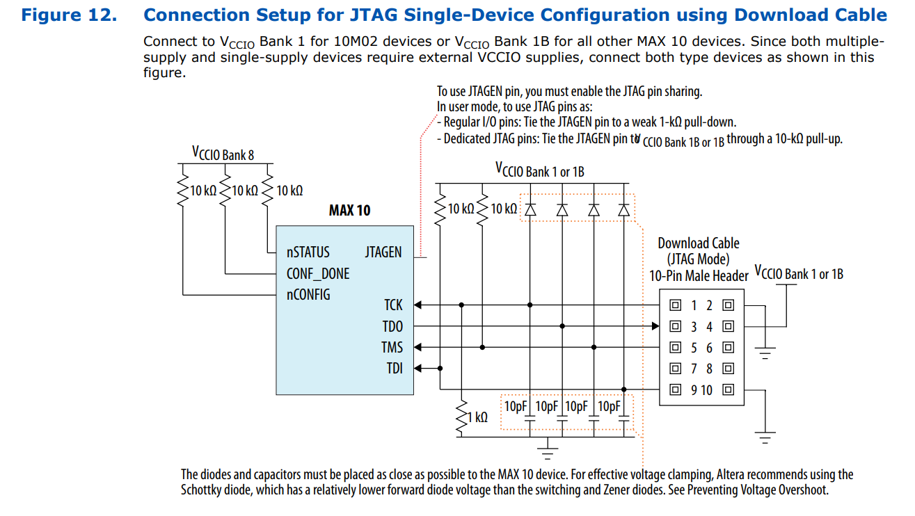

PIN 96 - CLOCK INPUT - DPCLK3

- Need two 16 pin headers for data output
- Need 3.3V & ground header
- Add test points - power, jtag, etc

Need 0.01uf bypass capacitor between PIN 2 and 4 (VDD and GND)
10k resistor could/should be direct between pins 138 and 139

Make sure
- device-wide reset (DEV_CLRn), devicewide output enable (DEV_OE) are disabled
- The diodes and capacitors must be placed as close as possible to the MAX 10 device. For effective voltage clamping, Altera recommends using the Schottky diode, which has a relatively lower forward diode voltage than the switching and Zener diodes. See Preventing Voltage Overshoot.
- EPAD is connected to ground
- Rules are updated to match pcb manufacturer
  - Design Rules -> Electrical -> Clearance
  - Routing -> Width -> Width
  - Routing -> Routing Via Style -> Routing Vias

PCB Routing
- Keep a minimum spacing between traces as three times the dielectric thickness

Questions
- Do I need to connect all power and ground on 3V3 and GND planes? Or use polygon pour?
- Is all the data lines next to each other going to be a problem?
- Does anything look wrong?
- Should I use cap/plug/via-in-pad vias so solder doesn’t accidentally flow into them?
- Do I have to worry about delay in signals from vias?
- jlcpcb

Components:
- 10uF Capacitor
  - CC0603KRX5R6BB106
- 0.1uF Capacitor
  - CC0603KRX7R7BB104
- 0.01uF Capacitor
  - C0603C103K5RACTU
- 10pF Capacitor
  - C0603C100J5GACTU
- Schottky Diode
  - CD0603-B0340R
- LED
  - QTLP650CRTR
- 10kΩ Resistor
  - RC0603FR-0710KL
- 1kΩ Resistor
  - RMCF0603FT1K00
- 330Ω Resistor
  - RC0603JR-07330RL
- 18 Pin Ribbon Cable Connector (16 Data Out + Clk + GND)
  - 0901301118
- 10 Pin Connector (JTAG)
  - 61201021621
- 6 Pin Connector (SPI)
  - 62000621121
- Two Pin Terminal Block (Power)
  - 691137710002
- 100 MHz Clock
  - ASEM1-100.000MHZ-LC-T

Cart Link: https://www.digikey.com/short/52f3775d

000 = Write to SRAM0
001 = Write to SRAM1
3 opp + 16 address + 16 data

010 = Set reset value for counter0
011 Set reset value for counter1
3 opp + 16 bit reset value + 16 unused bits

100 = Set phase increment for NCO0
101 = Set phase increment for NCO1
3 opp + 32 bit increment

110 = error/stopped
111 = running
32 unused bits

Memory Modes:
- Read:
  - FPGA is driving address
  - sram_we_n (WE pin, active low) = 1
  - sram_data = zzzz (high impedance)
  - sram_addr = output of counter
- Write:
  - FPGA is driving address and data
  - sram_we_n (WE pin, active low) = 0
  - sram_data = data from spi (bottom 16 bits)
  - sram_addr = address from spi (top 16 bits)

Current Problems:
- Reset value missing pin, connect to con led?
- Address values changing slower than sram stable time?
  - Might need to set WE pin to read while changing address and data

If remaking PCB:
- Fix order of JTAG pins
- Get 2.54 mm SPI header instead of 2 mm

Maximum Operating Conditions:
- Square Wave:
  - 50 MHz
  - 20001FFFF, 47FFFFFFF, 000000000, 00001FFFF, 7FFFFFFFF
- Other Waveforms:
  - Maximum non-harmonic frequency: 10 MHz (10% of system clock)
  - Assuming 10 samples per period, 1 MHz (1 μs period)
Minimum Operating Conditions:
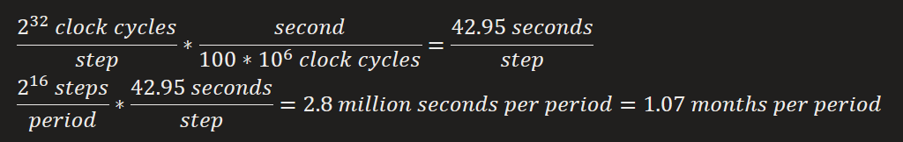
= 3.5527*10^-7 Hz = 355.27 nHz

1 month per cycle to 1 million cycles per second

32 bit tuning word allows for a precision of 100 MHz/2^32 values = 0.0232830644 Hz

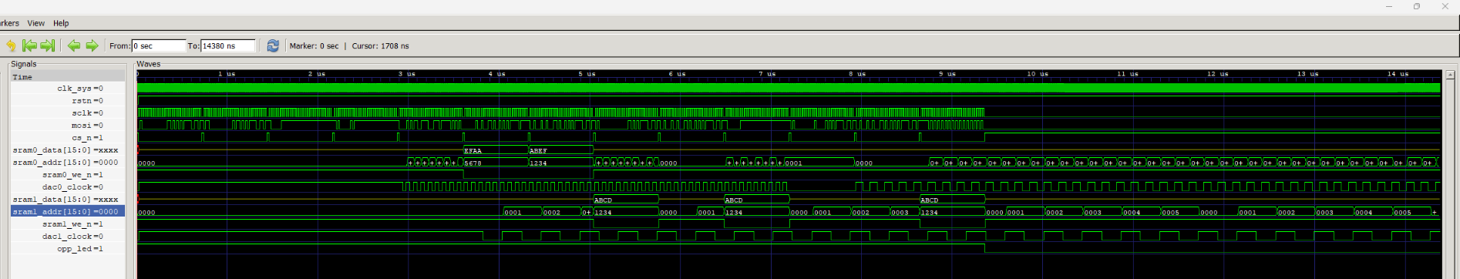
Verilog Testing Waveforms

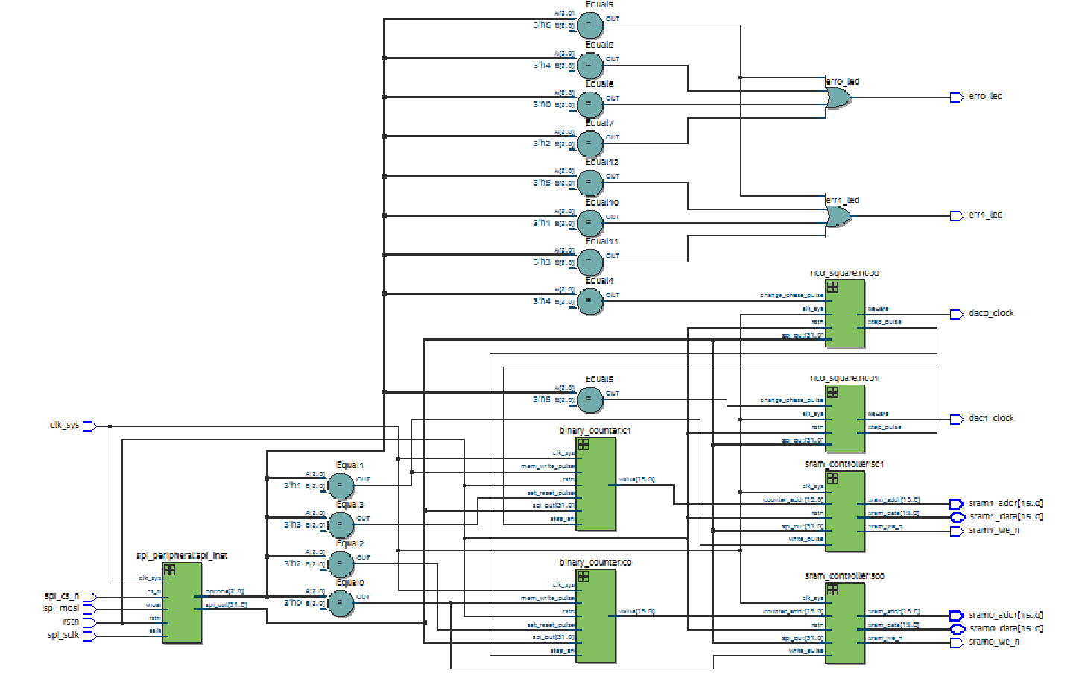
Netlist Visualization

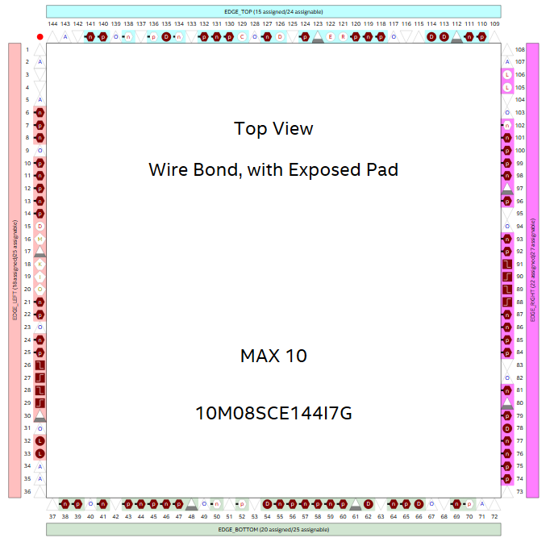
FPGA Pinout

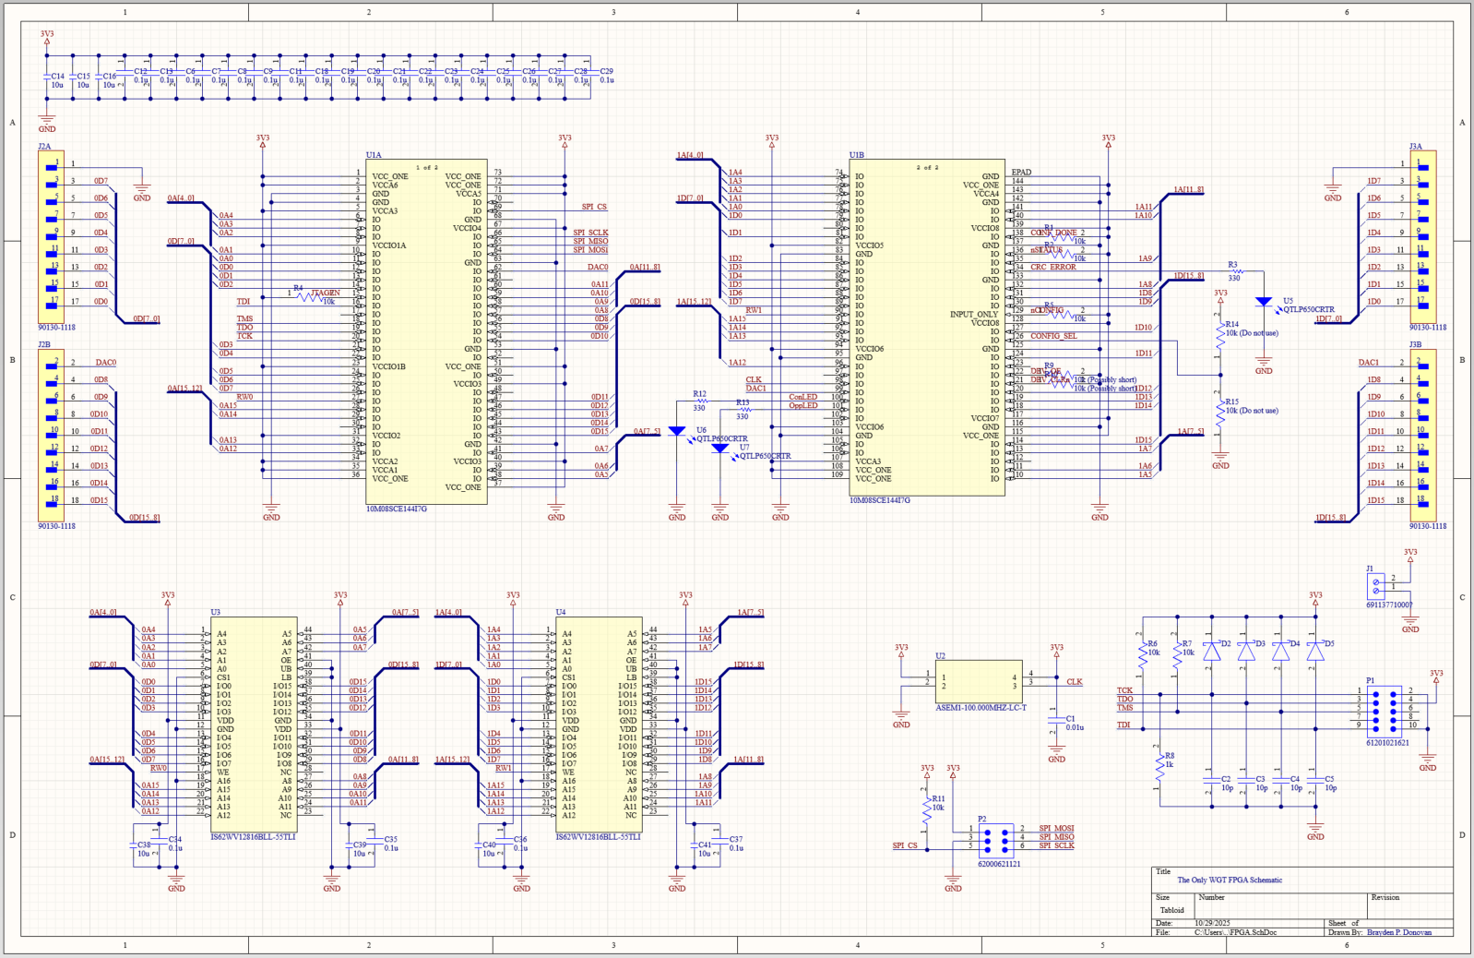
PCB Schematic

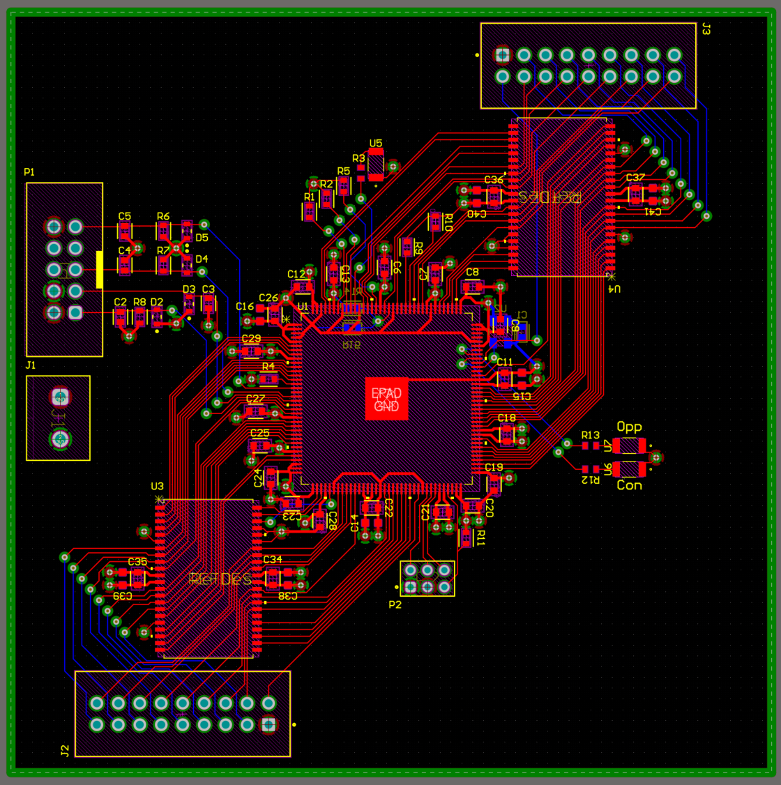
PCB Layout

